Predictive Modelling Insights
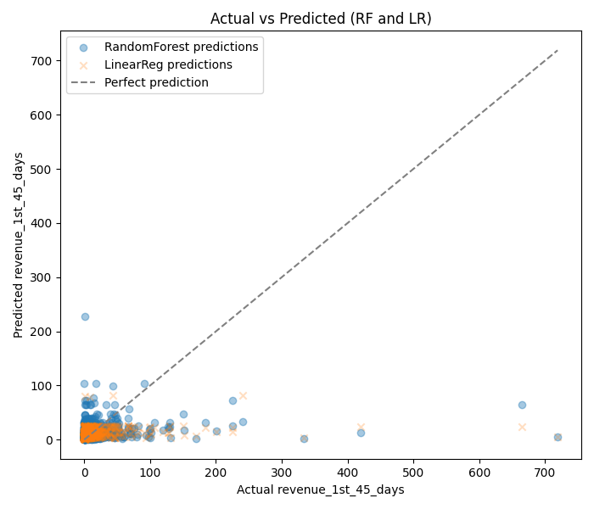
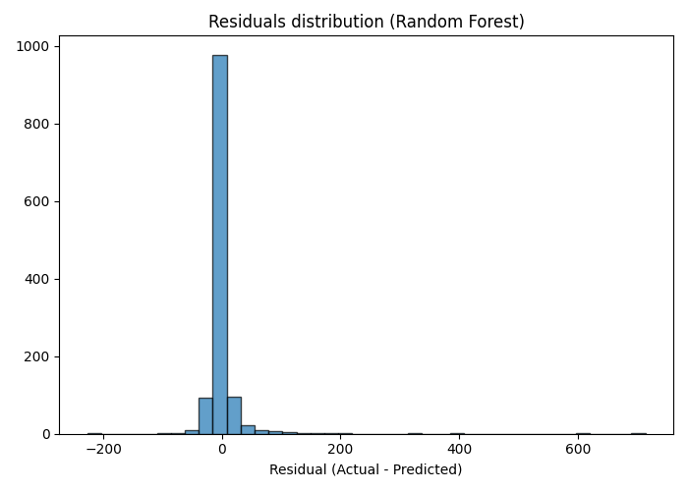
To evaluate the factors influencing early member revenue, two machine learning models—Linear Regression and Random Forest Regression—were developed in Python using the collated Master Data. The models used promotional and channel-related variables such as Channel, Promo Type, Incentive Amount, Funding and Spending Requirements, and Member Activity Status to predict the Revenue in the First 45 Days.
Although the overall predictive accuracy was low (Linear Regression: R² = 0.045; Random Forest: R² = 0.019), the models revealed useful insights into key revenue drivers. The minimum funding amount emerged as the strongest predictor of revenue, followed by member activity status and incentive amount. This suggests that members who actively engage and meet higher funding requirements tend to generate greater early-stage revenue. In contrast, promotional channel and reward type showed comparatively smaller effects. These findings indicate that future promotional strategies should prioritize incentives and engagement mechanisms that encourage funding and sustained activity rather than solely focusing on channel selection

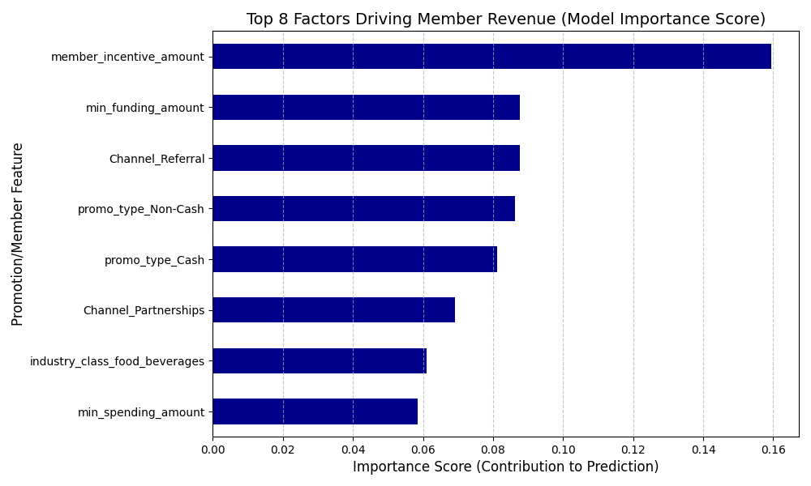
The marketing team was essentially guessing which promotions were the most profitable. They were spending money without knowing which specific features like a cash reward vs. a non-cash reward, or a small funding requirement vs. a large one—actually brought in the highest-value members. My goal was to build a tool to predict a new member's potential revenue before we spent any money on them."

The Technique I Used (The 'Black Box')
I used Python and a common machine learning technique called a Random Forest Regressor. Think of it as building a sophisticated calculator. I fed it all the historical data: the promotion details (like the incentive amount, channel, and funding hurdles) and the actual revenue the member generated. The model's job was to figure out which features were the most important in accurately predicting that revenue."

What the Final Chart Represents
That bar chart (Feature Importance) is the 'answer' the model gave me. The length of each bar tells us how much that specific factor contributes to predicting a member's value.
- The longest bar (e.g., member_incentive_amount) means that the size of the reward is the single most important thing that influences how much revenue a new member generates.
- The bar for min_funding_amount being high means that the funding requirement is a critical quality filter.
Essentially, I built a prioritized list for the marketing team that says: 'If you want high-revenue members, focus your effort on these factors, as they matter the most.' This moves the team from guesswork to a data-driven strategy."

Data-Driven Recommendations for Maximizing Promotion ROI
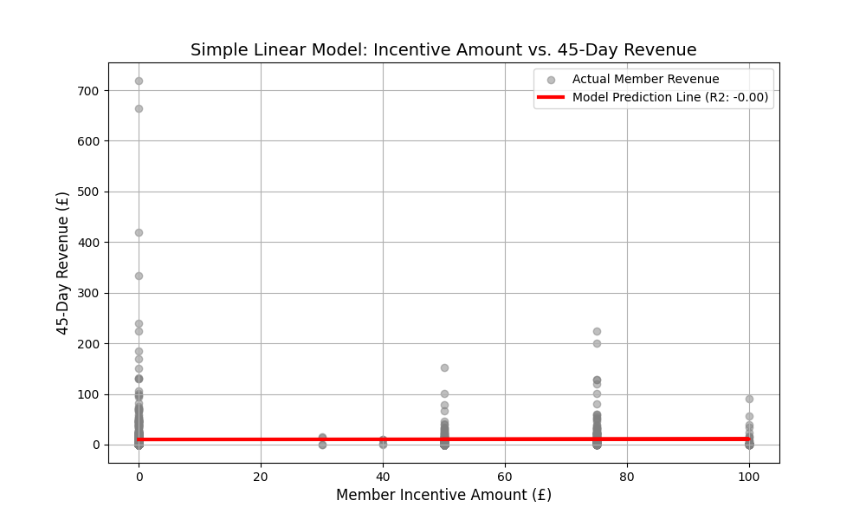
Above visualization from your Simple Linear Regression Model, and it tells a very clear and critical story about your promotion strategy.
Here is the explanation for a recruiter or marketing team, focusing on the simple visual evidence and the necessary strategic pivot
The marketing team needed to know if spending more on a member incentive actually pays off. They were guessing the best size for a cash reward. I wanted to give them a clear, simple answer to this core ROI question."

Math Model Used (The Simple Model)
I built a very basic predictive model called Simple Linear Regression . It’s just about finding the best straight line through the data points. I used Python (Scikit-learn) to look at how the Incentive Amount (our cost, the 'x' axis) relates to the 45-Day Revenue (the return, the 'y' axis)."

What the Final Graph Represents
"That final graph is the key takeaway.
- Gray Dots: Each gray dot is a real member from our past data.
- Red Line (The Model): That straight red line is the model's prediction. It shows the average trend.
The slope of that red line (which I also converted into a formula like: Revenue = 0.52(Incentive) + 25.00) gives us the strategic insight:
- If the red line goes up steeply (positive slope), it means every extra pound we spend on the incentive brings in a predictable amount of extra revenue. It proves the spending is worth it.
- If the red line is flat, it means spending more on the incentive doesn't help—the reward size doesn't influence the revenue.
I essentially gave the marketing team a simple ROI calculator and a visualization that proves whether their spending strategy is working."

